STATE OF NEW HAMPSHIRE
DEPARTMENT OF JUSTICE

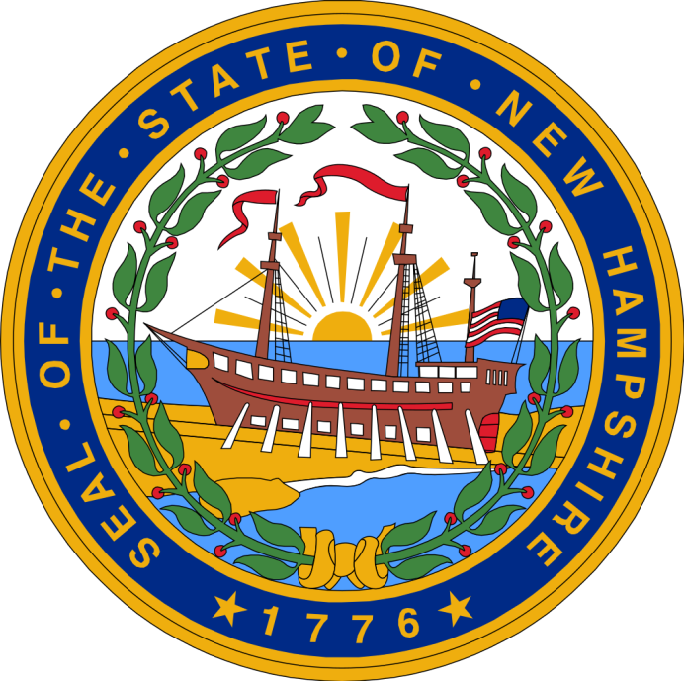

Residential Substance Abuse Treatment (RSAT)
Subgrant Application

Released Date: December 10, 2020
Application Due: 4:00 PM February 14, 2021

THE STATE OF NEW HAMPSHIRE DEPARTMENT OF JUSTICE
GRANTS MANAGEMENT UNIT

MISSION STATEMENT

The Grants Management Unit of the Department of Justice exists to make a difference in the lives of the citizens of New Hampshire by ensuring the proper use of federal funds for criminal justice purposes. The Grants Management Unit does this through:

* The professional administration of grant resources;

* The adherence to all underlying federal and state requirements;

* The coordination of federal criminal justice resources available to the state; and

* Efficient service and assistance

Program Title:

Grant Starting Date:
Ending Date:

Program Implementation Date:
DUNS #:

Federal Funds Requested $ SAM Expiration:

Agency Name:

Chief Elected Official/Head of Agency*

Name:

Title:

Address:

Telephone:
Fax:

E-mail:

Project Director

Name:

Title:

Address:

Telephone:
Fax:

E-mail:

Financial Officer

Name:

Title:

Address:

Telephone:
Fax:

E-mail:

*all grant-related documents will be sent to the head of agency unless head of agency requests that they be sent to the project director
Problem Statement (10 Points):

Program Narrative (65 Points):

Budget Detail and Budget Narrative (15 Points): See separate attachment.
DATA Collection and Reporting (5 Points):

Sustainability (5 Points):

I have read and understand the grant guidance provided with this application, to include specific guidelines and conditions, and other included materials provided with this application or solicitation.
In submitting this application, the applicant agrees to comply with the grant requirements set forth in the grant program guidance, grant award documents and other materials provided by the NH Department of Justice and/or the U.S. Department of Justice.

Name and title of Individual submitting application:
_______________________________________

Name of agency:
_______________________________

Date submitted: _______________

Please Note: This application is intended to be submitted electronically. Original signatures, if required, will be obtained at a later date if an award is made. Attachments listed on the checklist should be scanned and submitted with the application. All application documents should be submitted electronically.

APPLICATION CHECKLIST

Please be sure that the following sections are completed and returned with your grant application. Please include a completed copy of this checklist in your application.

Documents/Attachments due with the application:

Cover Page

Application (Problem Statement, Program Narrative, Data Collection and Reporting, Sustainability)

Budget Detail and Budget Narrative (See Separate Attachment)

Letter of Certification (See Page 9 of RFP)

Audit Report with Management letter (Electronic copy or web link)

__ Check if a paper copy is being mailed separately. (Electronic copy not available.)

__ Check if Organization does not have an Audit.

DUNS #/SAM Registration completed (Expiration Date…../…./…..)___

Grant Application Signature Page

____ Application Checklist

